Programming Languages Summary

01-Intro

Programming Paradigms
A prog ramming language is a tool for developing executable models for a class of problem domains. Basically all languages have some common constructs such as basic data types, variables, expressions, etc. They may differ in things like type declarations, concurrency constructs or generics. Shortly, a programming language is a problem-solving tool.
The most common styles contain the imperative style (good for decomposition), functional style (good for reasoning), logic programming style (good for searching) and the object-oriented style (good for reasoning).

02-Stack-based Programming

PostScript objects, types and stacks
PostScript is a language to describe the appearance of text, graphical shapes and sampled images on pages. It is a simple, stack-based language with minimal syntax.

Syntax
The PostScript syntax contains Comments (from % to next newline), Numbers (signed integers, reals and radix numbers), Strings, Names (Tokens consisting of regular characters), Literal names (start with slash), Arrays ([123 /abc … ]) and Procedures (enclosed in curly brackets).

Semantics
A PostScript program is a squence of tokens that is interpreted to manipulate the display and four stacks that represent the execution state of a program.
The Operand stack holds operands and results of PostScript operators. It is used for all computation
The Dictionary stack holds only dictionaries where keys and values may be stored.
The Execution stack holds executable objects (like procedures) in stages of execution. This is mostly hidden from the user and it used by PostScript to manage running procedures.
The Graphics state stack keeps track of current coordinates, etc. This helps working in different coordinate systems.

Object types
Every object is either literal or executable. Literal objects are pushed on the operand stack and Executable objects are interpreted.

Arithmetic operators

The operand stack
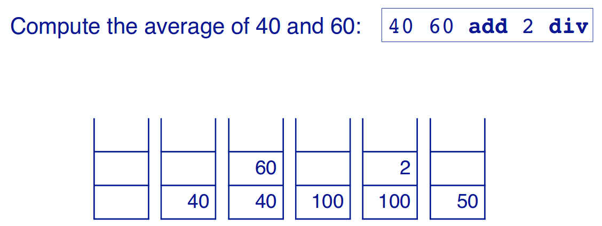
40 and 60 get pushed on the stack. Then add adds them (by consuming them) and pushes the result on the stack. Then 2 gets pushed and div divides them and pushes the result on the stack. Note that the numbers are literal objects, therefore they get pushed on the stack whereas the operators are executable and modify the stack.
Some arithmetic operators:
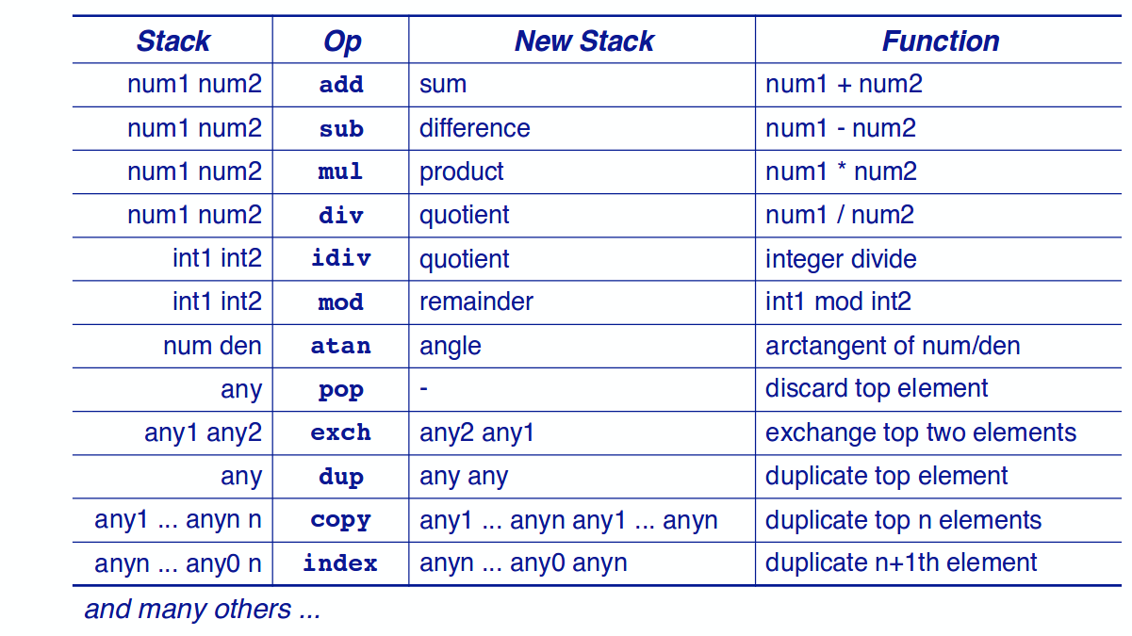

Graphics operators
Coordinates are measured in points where 72 points = 1 inch = 2.54cm. The coordinate system has its origin on the bottom left of a page.
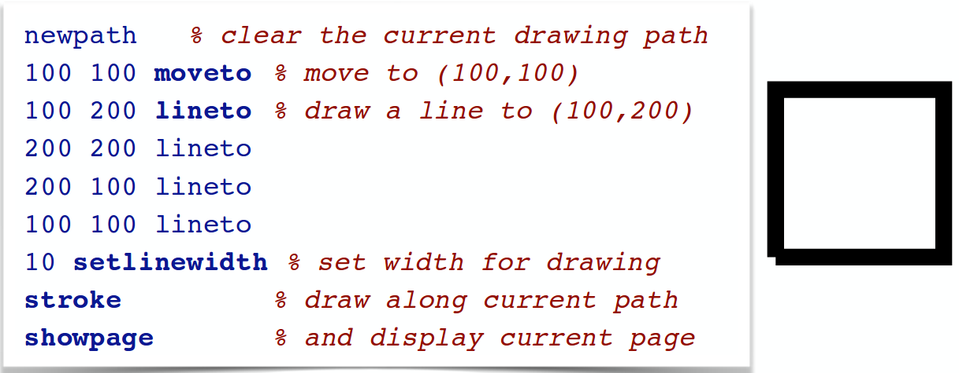
A path gets started at the current point (here 100,100). Then a line is added by lineto which takes the last two literal objects from the operand stack.
You can also print text, but for that you have to lool ip the desired font, scale it to the required size and then set it to the current font:
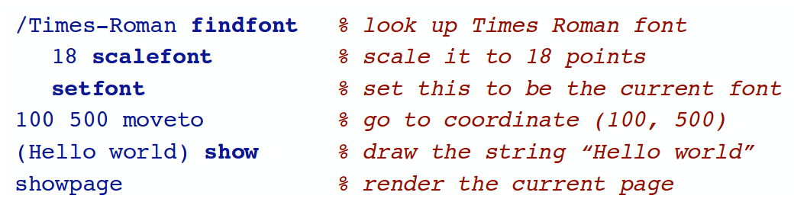

Procedures and Variables
Variables and procedures are defined by binding names to literal or executable objects. The keyword for this is def, what takes the top element from the stack and binds it to a literal:
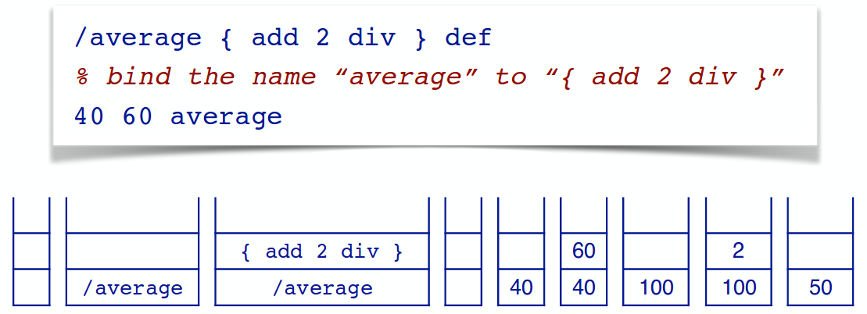

Once /average is defined, average becomes an executable operator.

Graphics state and coordinate operators

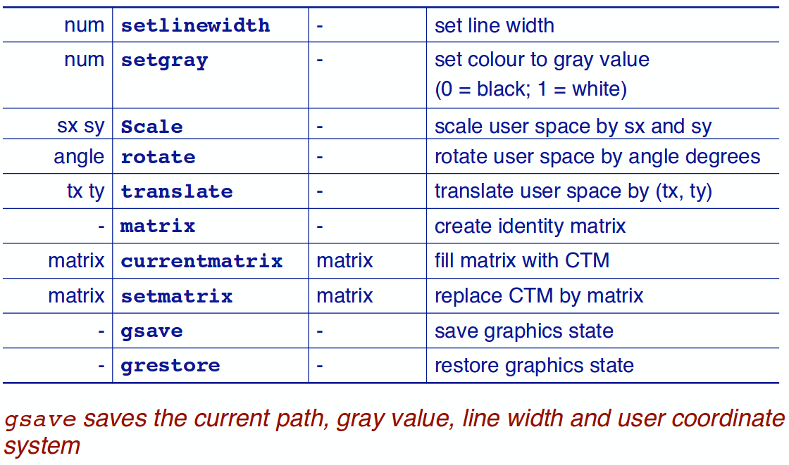

E.g. instead of having to paint a rotated box you can draw a normal box in a rotated coordinate system.

Boolean, control and string operators
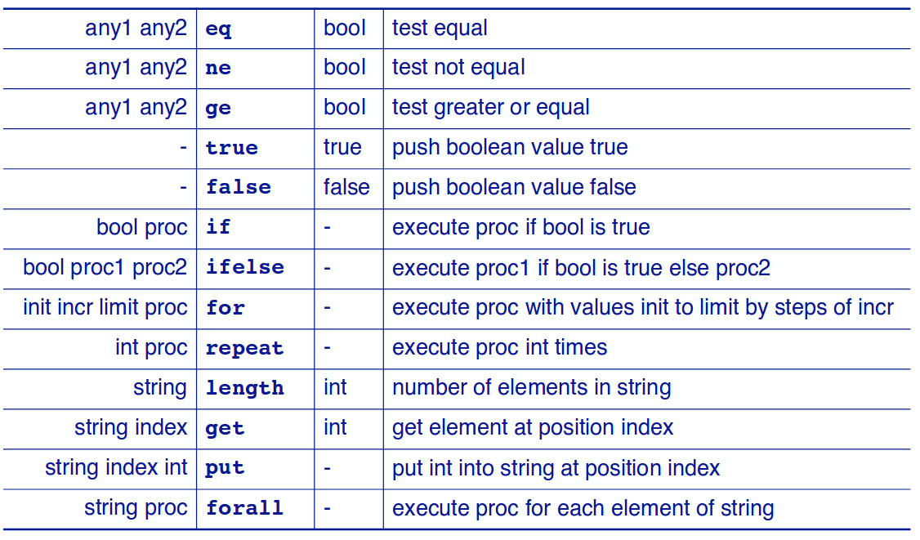

Arrays and dictionaries

Array and dictionary operators
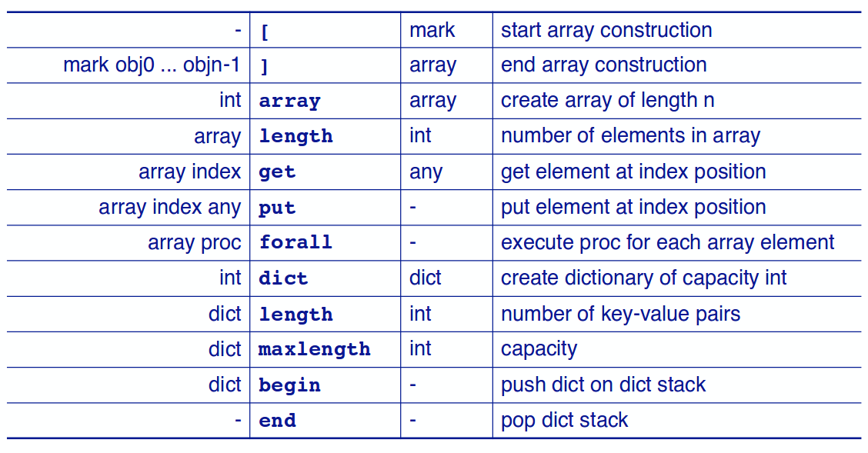

Dictionary in usage
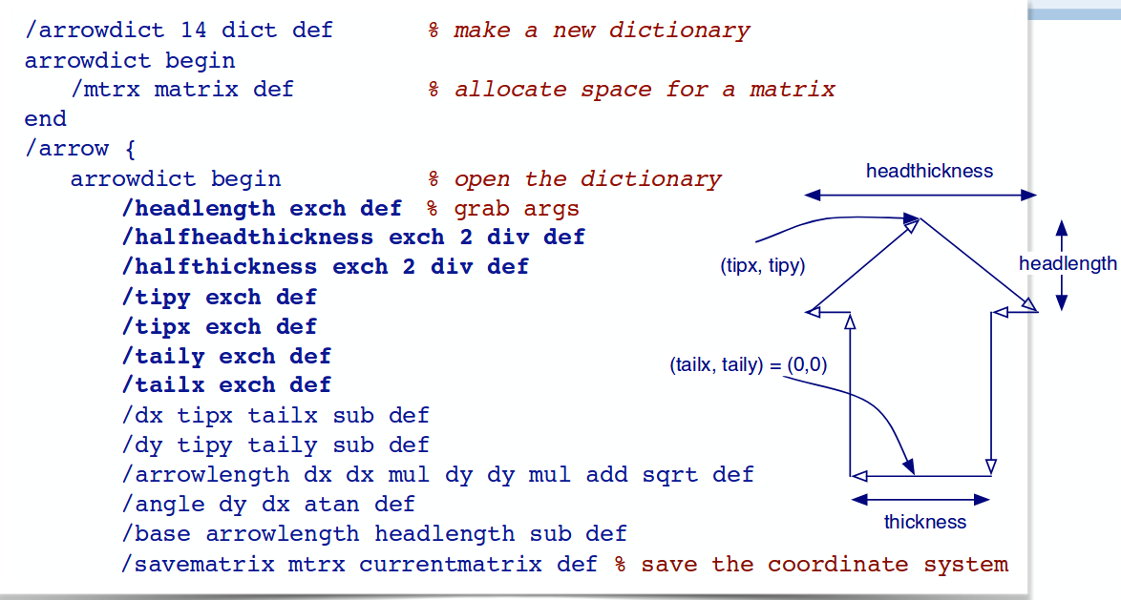
We allocate space/slots for 14 variables here. 7 serve as parameters which we can give the dictionary and the other 7 are for local usage. By defining this and pushing it to the dictionary stack we make sure that the names we use do not conflict with external names.

03-Functional Programming

Functional vs. Imperative Programming

